**COMP9032 Project User Menu**

Zihan, Lai ZID:5189667

1. **Wiring**

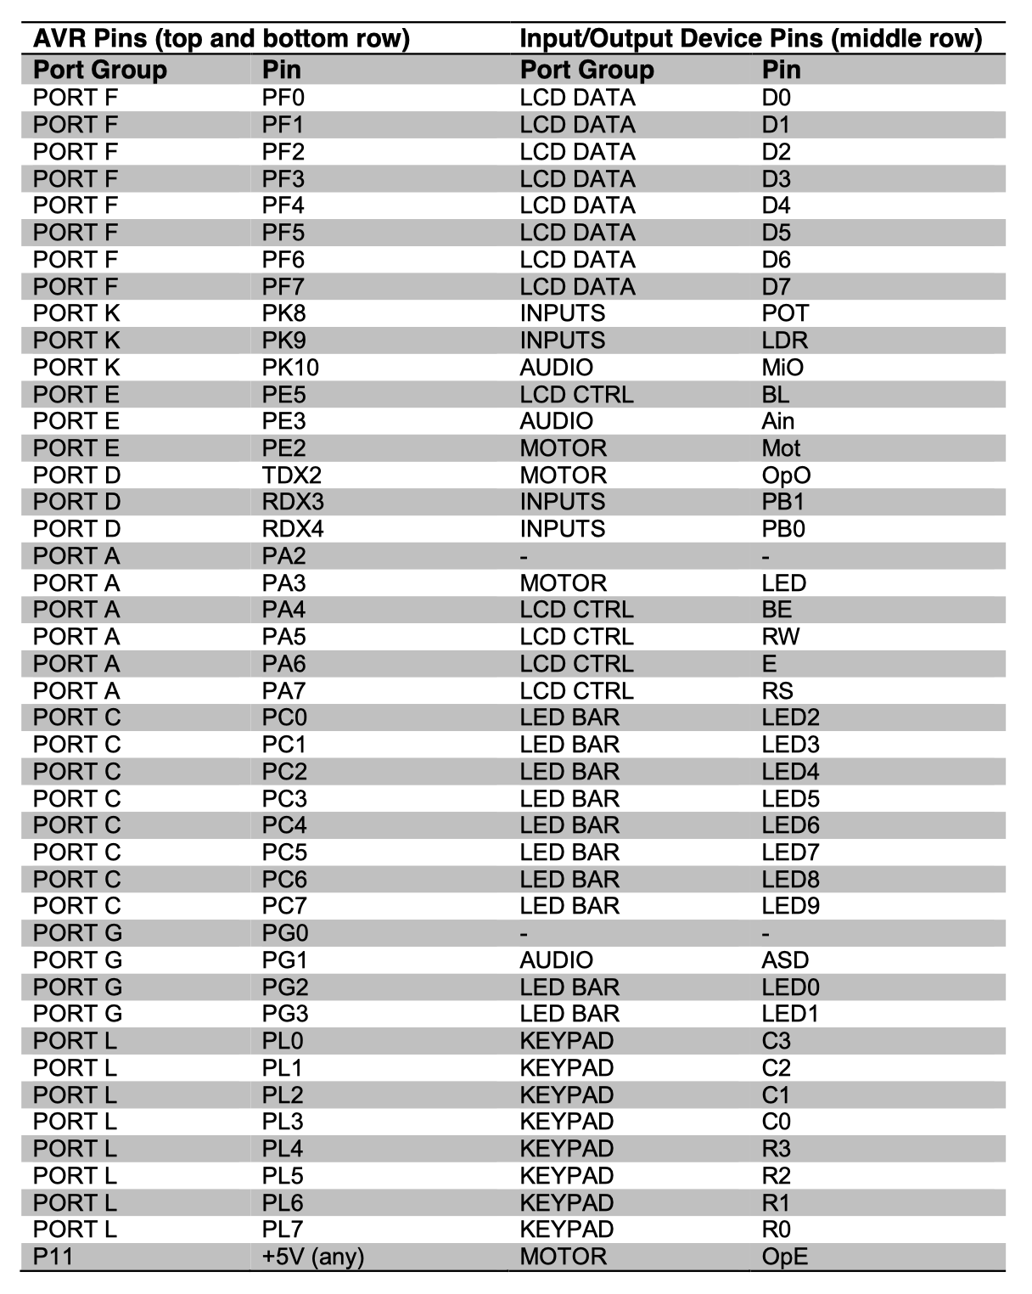

1. **Control procedure**

This project simulates Cup and Ball game on the board. Cup and Ball is an online game where a ball is shuffled under three cups and you guess the position of the ball. For each guess, you gain one point if it is correct or lose one point if it is wrong.

In this system, the push button is used to start the game; Three LEDs are used to represent the three cups, and these LEDs together with the motor are also used to indicate the ball shuffling among the three cups; the key board is used for the player to make a guess; the player’s score is displayed on LCD.

For the LED bar on the lab board, two groups of LEDs are used, as shown in Figure 2. Three LEDs, called cup LEDs, are associated with three cups (as mentioned before) and the four LEDs of the other group work as a result indicator for a guess. When a guess is correct, the indicator will flash.

After the simulation system is turned on (i.e. the lab board is powered on), the system is initialized and the ball is with an arbitrarily cup.

When the push button is pressed, the game starts and the ball is shuffled under the three cups.

When the player wants to make a guess for the ball position by pressing the push button again, the ball shuffle stops. And the score will display on LEDs.

When the player’s score becomes zero, the game will be reset to the initial start status; otherwise, the game can be continued by pressing the button for a new round of ball shuffle.